Shabbos Stories for
Parshas nitzavim 5781
Volume 13, Issue 54 27 Elul/September 4, 2021
Printed L’illuy nishmas Nechama bas R’ Noach, a”h

For a free subscription, please forward your request to keren18@juno.com
Past stories can be found on the website ShabbosStories.com

The Baby Carriage

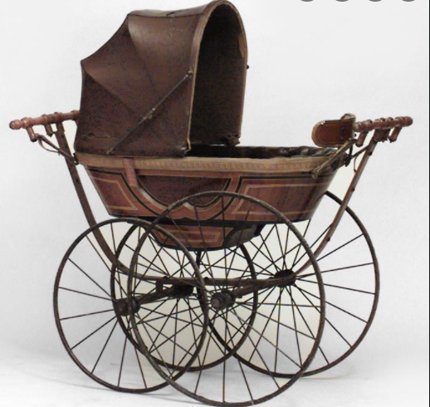

Rav A. Leib Scheinbaum writes a story that shows how deeply committed one can be in his belief, and to what extent this faith will carry him. It is a story about two Chasidim who would visit their Rebbe every Succos, and each year, they would stop overnight at the same inn.
One year, the innkeeper approached them humbly and said, “You know, I am neither a Chasid nor a student of your Rebbe, but I have a great favor to ask of you. My wife and I have been married for ten years, and unfortunately, we have not yet been blessed with a child. Can you please ask the Rebbe to Daven for us?” The Chasidim agreed to do so.
The very next morning, the innkeeper’s wife began walking around the neighborhood with an expensive baby carriage. When her friends came over to wish her a ‘Mazel Tov’, she explained that while she did not yet have a child, she soon would, since the Rebbe was going to Daven for her!
Hearing this, the two Chasidim were somewhat embarrassed, because they knew that Tefilos did not always produce the desired results. They said nothing and continued on with their journey, and faithfully carried out their mission when they arrived at their Rebbe.
When the two Chasidim returned the following year to the inn, there was a Bris in progress, as the innkeeper and his wife recently just had a baby boy. The innkeeper was quite elated and thankful to have these Chasidim, and he treated them as guests of honor.

“Rebbe, Is this Fair?”
Later on, when the Chasidim arrived at the Rebbe’s home, one of the Chasidim entered the Rebbe’s office and complained, “Rebbe, you do not even know the innkeeper! Yet, you Davened for him, and it was successful. I have been your trusted student since I was a child. I visit you every year just as my father did before me. Yet, I am married for twenty years, and I have made the exact same request of you, and my wife and I have still not had children. Rebbe, is this fair?” The Rebbe took his student’s hands and looked him in the eyes, and asked, “During all those twenty years, did you ever go out and buy a baby carriage? How great was your faith in the power of Tefilah in comparison to that of the innkeeper’s wife?”
Rav Scheinbaum taught that Bitachon, trust in Hashem, has to be unequivocal. We either believe, or we do not. To believe when it is convenient, to trust when there is no other alternative, is not trust. It is selfserving and hypocritical. When we say we believe, when we express our trust, we have to be prepared to purchase that baby carriage!

Reprinted from the Parshas Va’eschana 5781 email of Rabbi Yehuda Winzelberg’s Torah U’Tefilah.

A Young Couple’s Tragedy

In 5408 (1648) the fate of Eastern European Jewry became darkened with clouds and shrouded in heavy fog. A murderous Jew hater by the name of Bogdan Chmielnicki rose up from deep in the Ukrainian wasteland to marshal his hordes of Cossacks, and wage war against his Polish overlords.
While battling the Poles, he went out of his way to attack Jewish communities throughout Poland and Lithuania, massacring tens of thousands of Jewish men, women, and children. Terrible stories of devastation are recorded and many of the most luminous Torah scholars, as well as their families and entire communities, perished during those perilous times.
The city of Vilna also drank from the cup of woe. The Cossacks invaded the city and brought terrible carnage upon its inhabitants. The city was overtaken with terror and many took to flight, among them the Rosh Av Beis Din, R’ Ephraim Hakohen zt”l (author of Shaar Ephraim), along with his brilliant son-in-law, R’ Yaakov Ashkenazi zt”l (father of the renowned Chacham Tzvi) and his newly married young wife.

Many Hardships Awaited Them
They eventually crossed the border and settled in the province of Mehrin. Nevertheless, many hardships awaited them while en route. In his haste, and amidst the chaos of evacuation and fleeing, R’ Yaakov lost his way and became separated from his father-in-law and wife. He wandered alone for a while but eventually he was captured and fell into the hands of the murderous Cossacks.
The Cossacks took great delight in murdering innocent men, women and children, and often they would loot their valuables before dispatching them with the sword. When R’ Yaakov was lined up to be executed, something inexplicable happened. The murderous Cossack raised his sword, preparing to kill the young Jew, when at the last minute and for no readily apparent reason, he took pity on him and said, “Get up and flee from here to save your life.”
R’ Yaakov ran for his life. Fearing that he would fall into the hands of other murderers, he hid himself during the day among the dead for about a week. During the night, he got up and gathered plants which he ate to stay alive. In the end, the Cossack murderers left the area and R’ Yaakov began to wander in search of his wife and her father.

She Feared the Worst
Meanwhile, a number of weeks went by and his wife hadn’t heard of her husband’s whereabouts. She feared the worst. After much inquiry, two people came forth and witnessed that R’ Yaakov was slain by the sword of a Cossack, and they saw him lying on the ground with the rest of the Kedoshim. The witnesses were brought before the famous Rebbe, R’ Herschel of Krakow zt”l, and he ruled that she was permitted to remarry based on the eye witnesses’ account.
The young woman, however, was devastated. She was not even twenty years old and refused to accept that her brilliant husband was killed. Months went by but she would not be comforted. And suddenly, after six months, her husband showed up! An unbelievable surprise!
And he had an amazing story to tell. It was true that they held a sword to his head and it was true that he had lain there with the dead. However, unlike the others, his head hadn’t been detached! His executioner hit him with the flat side of the sword and instead of beheading him he knocked him to the ground! R’ Yaakov was miraculously saved.
R’ Herschel, however, was so distraught over his erroneous psak which almost led to a terrible sin, that he resolved to never issue a psak on these matters ever again. R’ Yosef Eliyahu Henkin zt”l always recounted this story in order to illustrate just how careful one should be before allowing an agunah to remarry.

Reprinted from the Parshas Ve’eschanan 5781 email of Rabbi Dovid Hoffman’s Torah Tavlin.

Predicting the Birth
Of Her Sister’s Baby

Rav Yechiel Spero relates a powerful, true story. Shimmy and Rochel were a young couple that had been married for ten years, and weren’t yet Bentched with children.
One day, Rochel’s sister, Ahuva, came to visit them with her husband, Simcha, and after the visit, Ahuva commented to Simcha, “It seemed to me that Rochel wasn’t feeling so well. Do you think she might be expecting? Did Shimmy say anything to you?”
Simcha replied, “No, he didn't tell me anything about that.” Ahuva said, “If she's expecting, I bet the baby will be born in the week of April 3rd next year.” Simcha said, “That’s a very interesting prediction. What makes you say that?” But Ahuva only said, “Let’s wait and see.”
As it happened, the next year, during the week of April 3rd, a baby was born to Rochel and Shimmy! What joy they felt after waiting ten years for this child! In a quiet moment, Ahuva was approached by her husband and he said, “How did you know?”
Ahuva responded, “I’ll tell you. Last year we had a problem with playgroups with our own child. We had a great play group with an excellent Morah. But then circumstances changed, and we had to take our child out of that playgroup and bring him to a different play group. Because of that, I started paying the new Morah and I couldn’t pay the first one any longer.

Demanding Payment for Two More Months
“However, my original playgroup Morah insisted that we agreed that I would pay her until the end of the year, and to avoid a conflict, even though it was difficult, I paid her through June. But then she said that according to her, the year ends in September, and not in June, and I would have to pay her for two more months.
“I didn’t know what to do. I asked different teachers what their policy was, and I asked other mothers, and everyone said that the end of the year is June, not September. In fact, I went to some Poskim to see Halachically would I am required to do, and they also told me that I have no responsibility to keep paying the Morah. “Then, I was discussing everything with my father, and he agreed that I don’t have to pay. Nevertheless, he advised me and said, ‘I can't tell you what to do with your money, but I have a suggestion.’
“He said, ‘You know, your sister and brother-in-law really need a Zechus. Maybe this could be the Zechus that helps them. Perhaps you should just let it go. Pay the extra few months to the Morah, in the merit that they should have a child.’ And I listened to him. I started to pay our old Morah money that I did not think she deserved. In fact, she was not even entitled to that money.

Exactly Nine Months Later
“But I didn’t want to cause a Machlokes. I didn’t want to cause a disagreement. And I said that in this Zechis, let Rochel have a child, and the first payment I made was on July 3rd. Exactly nine months later, in the week of April 3rd, is when the miracle occurred, and that’s how I knew the date the baby could be born!”
Rav Spero comments, “When we are willing to go the extra mile, even when it doesn’t always make sense, then Hashem does so as well, and we can see how far the results will go!”

Reprinted from the Parshas Va’eschana 5781 email of Rabbi Yehuda Winzelberg’s Torah U’Tefilah.
Did You Remember to Pray?

A Goy once stole some valuables and dumped it in a Jew’s house. The police arrested the Jew, and [the judge] sentenced him to be hung in a week, despite his pleading that he was innocent. The K'sav Sofer (Rabbi Avraham Shmuel Binyomin Sofer, 1815-1871) spent this week with sleepless nights and long trips to the authorities, in a vain attempt to save this Jew.

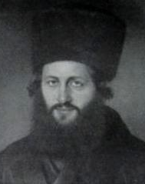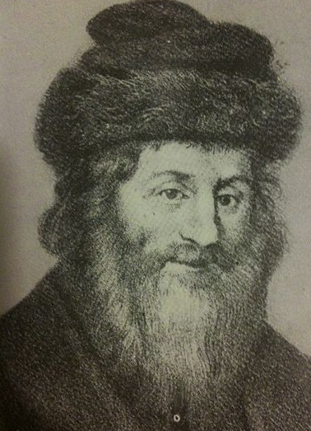
Ksav Sofer and his father the Chasam Sofer

The night before the hanging, his father, the Chasam Sofer (Rabbi Moshe Schreiber, 1762-1839) came to him in a dream, and accused him for not doing anything for the Jew. [For despite all his efforts, the main effort, Tefila wasn’t really done].
The K'sav Sofer woke up the whole town, and they got together to daven for hours. The next day, as the Jew was being led to be killed, the Goy suddenly decided that he should admit the truth; which he promptly did, and the Jew was saved!

Reprinted from the Parshas Va’eschanan-Nechama 5781 email of the Rabbi Yaakov Shur’s Bitchon Weekly – Stories of Novardok.

The Twelve Bottles of Gold
By Rabbi Dovid Goldwasser
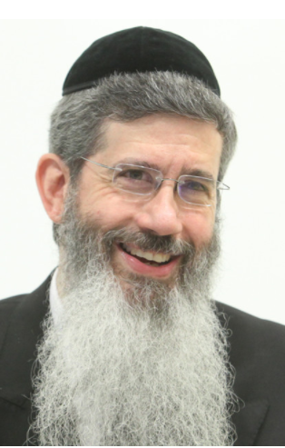

The Zohar relates an extraordinary episode concerning the value of a neshamah.
R’ Abba once noticed a child playing in the streets. He asked the boy his name and then inquired, “If I take you to yeshiva would you learn Torah?”
The boy, Yosi, asked, “How much would you pay me?”
R’ Abba was very anxious to save his soul, and answered, “Whatever you ask for.”

The Boy Asked for 12 Bottles of Gold Coin
The boy asked for twelve bottles of gold coins, and R’ Abba agreed.
Yosi began to learn with great enthusiasm, anticipating the substantial reward that he had been promised. He continued for many years, and all who knew him were deriving great nachas from his success. Only the yetzer hara was deeply disappointed, as the relationship the two had enjoyed had been severed.
The Evil Inclination badgered him, “Do you really believe that R’ Abba will give you those twelve bottles of gold coins? He doesn’t even have twelve bottles.”
Yosi became upset, and stopped learning. When R’ Abba saw Yosi with his head on the table, he worriedly asked him, “What happened?”
“Do you remember you promised me twelve bottles of gold coins when we first met?” asked Yosi.
R’ Abba replied, “I promised you I will give you the money, and you can trust me. Return to your learning.”
R’ Abba was troubled, though, because he, in fact, did not have the money, and when he came home, he confided his concerns to his wife.
“Don’t worry,” she said, “If you trust in Hashem, He will provide, as it says (Iyov 4:5), ‘And now when it [the test] befalls you, you become weary? It touches you and you are bewildered!’ There is no need for agitation.”

A Knock at the Door
As they were eating their evening meal, there was a knock at the door. An elderly man, with a bundle on his back, stood in the doorway, crying that he had a matter of life and death to discuss with the Rav.
The elderly man revealed that the past Shabbos R’ Yochanan had expounded in the bais medrash that one who did not have a daily established time for Torah study would have difficulty standing at techiyas hameisim (resurrection of the dead). “I have been a farmer for seventy years and have been prosperous. What will I do with this wealth?” he cried as he emptied his bundle of gold coins on the table. “I cannot take it with me. Perhaps you can buy a little Torah with this gold,” he begged.
R’ Abba’s eyes lit up as he told the old man about Yosi, and an agreement was reached whereby the elderly man could assure his share in olam haba and Yosi would acquire the gold coins he had been promised.
Years passed and Yosi became one of the greatest sages of the yeshiva. One day, however, he cried out, “Where is that elderly man? I hope he is still alive!’
“Why?” everyone asked.

All the Gold in the World Isn’t
Worth One Word of Torah
“I just learned (Talmud Yerushalmi) that R’ Brachya states that all the gold in the world is not equivalent to the magnificence of one word of Torah. How foolish I was to sell fifty percent of my Torah to that elderly man for his gold coins. It was an erroneous transaction!”
Although R’ Abba tried to calm him down, Yosi refused to be placated. The search began for the elderly man, and he was eventually found.
The elderly man would not accept renunciation of the deal, and an argument ensued. R’ Abba then noted with a smile, “I see that there is great joy in Heaven. Let the gold be distributed to the poor, and you will both merit a wonderful share in the World-to-Come.”

Reprinted from the July 22, 2021 email of The Jewish Press.
“And what is Your Name?”
By Rabbi Levi Garelik

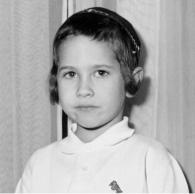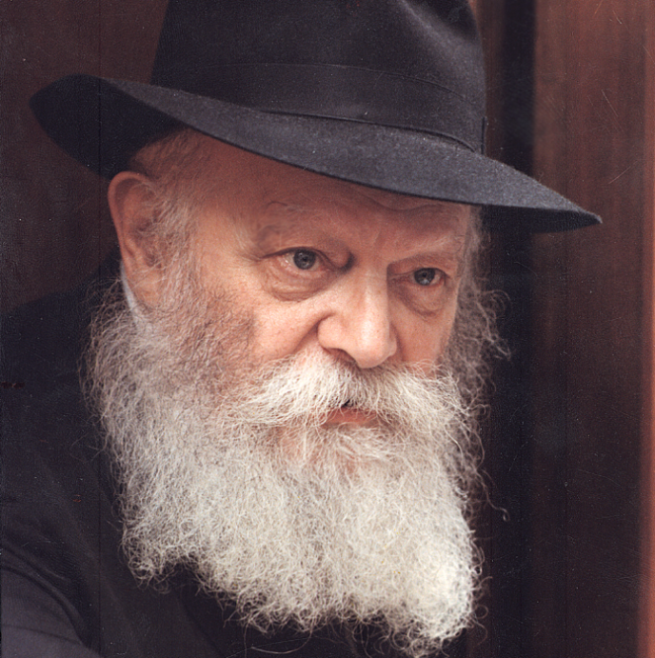
Rabbi Levi Garelik as a young boy and the Lubavitcher Rebbe, zt”l

My parents — Rabbi Gershon Mendel and Rebbetzin Bessie Garelik — were sent to Milan, Italy, by the Rebbe over sixty years ago, before I was even born. So, I am privileged to be one of the first children born to his emissaries. And I am also one of the first people to be named Levi Yitzchok after the [Lubavitcher] Rebbe’s father.
When my mother brought up the idea of giving me this name, my father agreed because, as a child, he had spent time in Almaty, Kazakhstan.
That was where Rabbi Levi Yitzchok was exiled by the Soviets for the crime of teaching Torah and supporting Jewish religious practice. Although my father never met Rabbi Levi Yitzchok — since even being in the vicinity of a Schneerson back then was considered a crime — he felt a connection to him. Eventually, my father and his sisters grew very close to the Rebbe’s mother, Rebbetzin Chana, and they all escaped Russia together. But that is another story.

A Framed Picture was
Given to Rebbetzin Chana
Later, when I was a toddler, my parents sent Rebbetzin Chana a framed picture of myself, and she wrote back expressing her gratitude. It apparently meant a lot to her that I was named after her husband because she put my picture on the breakfront of her dining room. And she even mentioned to others, “I have my Levi Yitzchok.”
But I never got to meet Rebbetzin Chana because the first time I visited New York she had already passed away. That visit took place in the winter of 1967 when I was seven, and my mother brought me along with my five siblings to meet the [Lubavitcher] Rebbe [Rabbi Menachem Mendel Schneerson, zt”l, 1902-1994].

Trip Timed to Coincide
With Yud-Tet Kislev
We timed our trip to coincide with Yud-Tet Kislev, the 19th of Kislev, when Chabad celebrates the “Rosh Hashanah of Chasidism” because on this date in 1798, the Alter Rebbe, the founder of the Chabad Movement, was freed from Czarist prison.
The day before we left Italy for America, the Italian translation of the Alter Rebbe’s seminal work, the Tanya, came off the press. This project was very important to the Rebbe, and he had appointed my father to make it happen.

Chosen to Make the Presentation
We would be bringing him the first copy, and it was decided that I should be the one to make the presentation. We would all wait outside 770 as the Rebbe left to go home in the evening, and that is when I would hand him the new Italian Tanya.
I will never forget the scene. We had just come from the airport and we were standing out in the street; it was already dark, as it was December. The light was shining from the window of the Rebbe’s office, and we knew that when that light went off, he would be coming out shortly.

Had Never Seen the Rebbe Before
Before this, I had heard the Rebbe’s voice on the recordings of his farbrengens, but I had never seen him. Now, finally, I did!
The Rebbe walked down the front pathway to where we were standing, and then stopped. We all recited the blessing of Shehecheyanu and the Rebbe responded Amen, and then I stepped forward with the Italian Tanya, which was not yet bound — it was just loose pages covered in plastic. The Rebbe took it from me with both hands, looked at it, and said, “Thank you!” And then he got into his car and left.

Attended a Shabbat Farbrengen
The following Shabbat, there was a farbrengen, and I was so excited to participate. I was given a box on which to sit right next to the Rebbe’s table, and that is where I stayed through the entire event. Although I spoke Yiddish, I didn’t understand much of the talks the Rebbe gave, but the part I liked most was the singing — when the songs started, I felt I was in the Garden of Eden.
Later, when I was older and understood more, I looked at the transcript of that talk and saw that the Rebbe said, “One of the milestones reached in honor of Yud-Tet Kislev was that the Tanya was just printed in Italian….”
He spoke about the whole idea of translating chassidic teachings into foreign languages, and that by doing so we are actually refining these languages and preparing the world for Mashiach.

Handed a Piece of Cake
When the Rebbe finished speaking, I suddenly saw people pointing at me, and saying “Go, go… Go over! The Rebbe is calling you.” I looked up and saw that the Rebbe was smiling towards me, so I walked over to him and he handed me a piece of cake. I took it and sat back down on my box.
After a few weeks in New York, it was time for us to go back to Italy. We were standing together in the hallway of 770, when the Rebbe’s secretary approached us. “The Rebbe wants to see the Garelik family for a private audience right now!” he announced. We were entirely unprepared for this, but the Rebbe had summoned us, so we went in.
The Rebbe spoke to my mother for a while. Later I found out that most of the conversation was about my education, because at the time the Lubavitch school in Milan was in its infancy and most of my learning was private.
After speaking with my mother and my sister, the Rebbe turned to me and asked in Yiddish, “What is your name?”

What is Your Name?
“Levi Yitzchok,” I said.
“What are you learning?” he continued, smiling all the while.
“… Parshat Toldot.”
“What does Toldot mean?”
“It means ‘children.’”
“Whose children?”
“The children of Yitzchak.”
“And who were Yitzchak’s children?”
“Yaakov and Esav,” I answered correctly.
“And which of them was more observant?” the Rebbe continued, using the Yiddish word “frum” for “observant.” Now, I knew Yiddish, but I had not heard this term before. So, I turned to my mother and said in Italian, “Non capisco quella parola — I don’t understand that word.”

Rephrased the Question
But, of course, the Rebbe spoke Italian, so he immediately rephrased himself, asking me, “Who was better?”
I knew the answer to that: “Yaakov!”

“In that case, let’s talk about Yaakov. Do you know if he had any children?”
Sure, I knew. Yaakov’s twelve sons became the Twelve Tribes of Israel. To my luck, my uncle had given me a puzzle which had all their names, so I was hoping that the Rebbe
would ask me this question, and he did.
I jumped on it, and I started reciting their names, until the Rebbe stopped me at the sixth with: “Good enough!”
But he was not done yet. “What was the name of the third one again?”
“Levi,” I answered.
“And what is your name?”
No problem answering that question.

The Rebbe Got Serious and Looked Me Straight in the Eyes
Then the Rebbe got serious and looked me straight in the eyes. “And whom are you named after?”
Now, in Italian there is a very elegant way to say “your,” but I did not know the equivalent in Yiddish. So instead of saying, “your father,” which I felt might be disrespectful, I said, “the Rebbe’s father.”
When I said that, the Rebbe gave me a massive smile. He then called me over and gave me a prayer book, which I treasure to this day.
That was my first audience with the Rebbe when I was a small child. There were many others that followed, but this one will always stand out in my memory.

Rabbi Levi Garelik is a lecturer and author of multiple books on Jewish law. He resides in Brooklyn, New York, where he was interviewed in February of 2021.

Reprinted from the Parshat Va’etchanan email of Here’s my Story, an oral history project of the JEM (Jewish Educational Media) Foundation

“Father! What is This?”
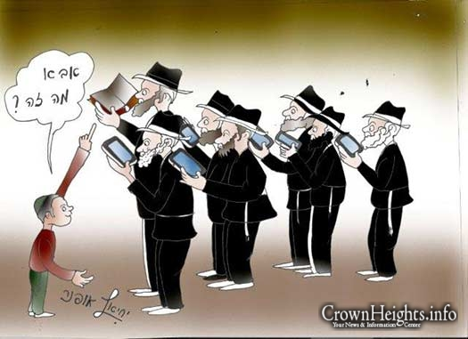
Caricature artist Yechiel Ofner drew up what tomorrow’s children may ask their father. With the advent of technology permeating deeper in our day to day lives, seforim and books may become obsolete. [Editor’s Note: How can they pray on Shabbos and Yom Tov?]
Reprinted from the July 23, 2021 website of the CrownHeights.info
Your Money or Your Kids?

Later in the Parasha Mattos-Masei 5781 we are told that the descendants of Gad and Reuven said to Moshe that before going to war, “We will build pens for the flocks of sheep and cities for our small children (32:16).”
The phrasing suggests that they gave priority to their flocks over their children. Why would they do this? Moshe later criticized them by reversing the order of the words they used, “Build for yourself cities for your small children and pens for your flock.”
We also may be guilty of the same thing with our children. At the time of the pidyon haben the kohen asks the father “Do you want the money or your son?” Naturally, it is not a question that is meant to indicate an actual real-life choice, and the kohen would refuse to take the child if the father said he preferred the money. The question is intended to send a message to the father about his duties as a parent and how he must always put his child first.
There’s a famous modern-day parable about the son of a lawyer who once asked his father, “Dad, how much do you charge for an hour of your legal services?” The father replied, “I charge $200 an hour, son. Why do you ask?” The son answered, “Because I saved up $200, can you spend an hour with me?”

There’s another story of a teacher who was marking her students’ homework one night after dinner while her husband was sitting nearby, playing a game on his cell phone. Suddenly, tears welled up in her eyes. “Why are you crying my dear?” her husband asked.
“Yesterday I gave my class a writing assignment called ‘My Wish,’ “she told him. “OK, and what’s making you cry?” he asked again, keeping one eye on his game. “The last paper moved me so much it made me cry. Listen, I’ll read it to you,” she replied, wiping her eyes.
“My parents love their smartphones very much. The care about their smartphones so much that sometimes they forget to care about me. When my father comes home from work tired, he has time for his smartphone but not for me. When my parents are doing some important work and their phones rings, they will answer it right away, but they will not answer me…even when I’m crying. They play games on their phones, but not with me. When they are talking to someone on their phones, they never listen to me, even if I’m telling them something important. So my wish is to become a smartphone.”
Now it was the husband who was wiping his eyes. “Who wrote this?” he asked quietly. She looked up at him and said, “Our son.”
Let us not sacrifice our family and relationships over the pursuit of material things. Smartphones are here to make our lives easier, but not to control us, and make us addicted and unsociable. It’s not too late to return to a real family life, back to the old days when we didn’t have the Internet and computer games. Put down that phone for a while. Talk to your children, your spouse, or your friends. Set a good example for your children. Whatever you do, they will also do. Talk to the people you love and make sure they feel loved. And you can receive love from them too.

Reprinted from the Parashat Mattot-Masei email of Jack E. Rahmey based on the Torah teachings of Rabbi Amram Sananes.

